Chorus Contract

Student Name (print): _______________________________________________________________

Student Grade: ___________ Student Homeroom Teacher: ________________________________

For the Chorus Member:
I am choosing to become a member of the Gulf Breeze Elementary School Choir. By doing this, I am committing to 1) the attendance policy, 2) the student conduct requirements, 3) wearing the correct uniform, 4) participating to the best of my ability and 5) being responsible for my actions, representing myself and my school with courteous behavior, and careful attention to my learning and the learning of others.

Student Signature:___________________________________________________________________

For the Chorus member’s parent/guardian:
I will support my child’s membership in the GBE Choir by making sure he/she complies with the above requirements and requirements stated in the Acceptance Letter. I understand that after two unexcused absences from Chorus, my child will no longer be allowed to be a member of the Chorus. I will communicate any upcoming absences from rehearsal with Mrs. Singletary.

Parent Name (print):__________________________________________________________________

Parent Signature:_____________________________________________________________________

Parent Phone Number: ________________________________________________________________

Parent Email Address(es):______________________________________________________________

Chorus Shirt Order Form
(Payment for the shirt is included in the $15 Choir Participation fee)

All Choir members will need to purchase a shirt for performances. If writing a check, please put the student’s name and “Choir” in the memo field of the check. Make checks payable to Gulf Breeze Elementary School. Do not combine check with other fees (including band). If you are unable to pay, please speak with Mrs. Singletary.

If you would like to purchase any additional shirts (duplicates, for siblings, for parents) the price is $10.

Size | Quantity
Youth Small
Youth Medium
Youth Large
Adult Small
Adult Medium
Adult Large
Adult XL
Adult XXL
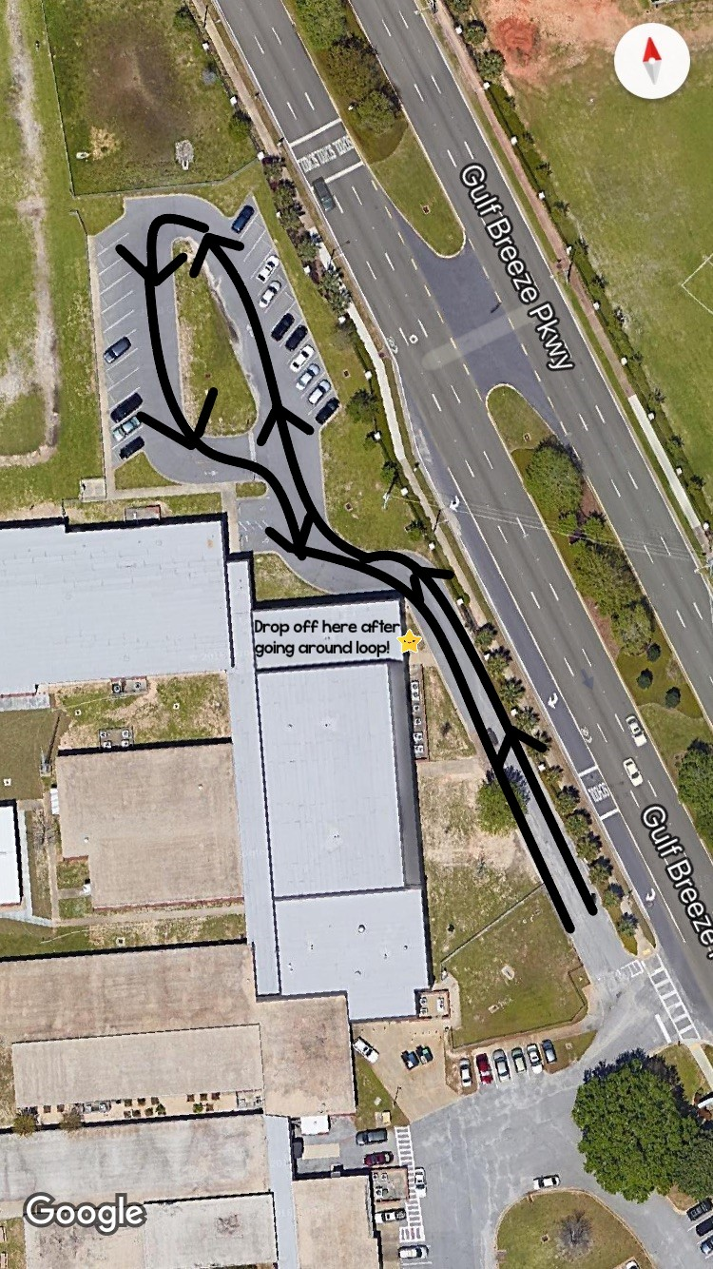
CHOIR PICK UP

Choir pick up is near the North/4th Grade parking lot. To avoid having children cross traffic, you MUST first pass the music room, drive around the loop (shown) and then pick up your child. Pick up will be promptly at 4:00pm.

Please remember that all of Choir is being picked up at the same time. There will most likely being a line of cars waiting. I will do my best to help students into their cars as quickly and as safely as possible. However, patience is key!

